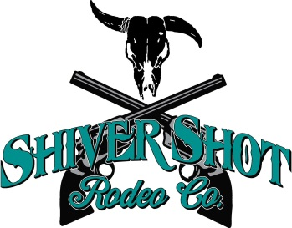Sponsorship Form
Oklahoma Kansas Youth Rodeo Association
Sponsor Information(please print or type)
Company/Name
Billing Address
City |  | State | ZIP Code
Telephone (home/cell)
E-Mail

Sponsorship Level (select one)
( ) Platinum  $500+ | ( ) Bronze  $50 - $99
( ) Gold  $250 -$499 | ( ) General  $25 -$49
( ) Silver  $100 -$249 | ( ) Selected Event Sponsor  $75 Event ______________________________

Payment and Additional Information
Payment Type: ( ) cash ( ) check ( ) other ____________

NOTE: Please make all checks payable to “Shiver Shot Productions”
Additional Information:

OKYRA Member:__________________________________________________ | Date:
Contact Information:KistinTussey 316-308-6173Email: shivershotproduction@gamil.com

